Spelling
Use the look, say, cover, write, check method to learn the spellings of words which you will be using in your writing for our new core text ‘The Hunter’.

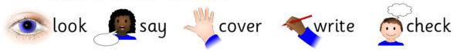

hunter | elephant | poacher
Jamina | murmur | herd
zebra | storm | slipped

English
In English this week, we have been exploring our new core text ‘The Hunter’ by Paul Geraghty. Before reading the book we made predictions from images in the book. Now you have read it, can you say if you were correct in your predictions?

 | My prediction was…. | Was I correct?
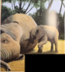 | I predicted that... | My prediction was correct because…  My prediction was incorrect because...
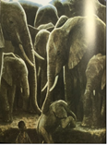

Maths
Let’s practice our addition and subtraction with 2 digit numbers.
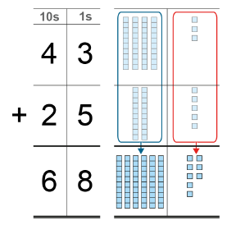
You are first going to draw how you are going to add the 2 digit numbers and next to the drawing write out your column addition. Have a look at the example.
Now try completing the following sums in your book:
68 + 11 =
24 + 33 =

Times Tables
Find the sets of 3 numbers from our 4x table number sentences and colour them in. They may be horizontal, vertical or diagonal. Write the sums for the ones you have found and coloured in, in your book, e.g. 4 x 4 = 16.
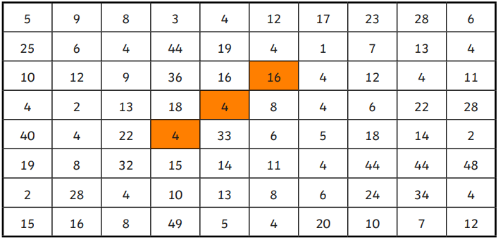

Reading
Remember to read for at least 30 minutes every day. Can you record any comments, questions or new and exciting words you have read?

