Spellings
Practice spelling these year 4 common exception words using look, cover, write and check method.

Look | Cover | Write | Check
accident
actual
experience
continue
century
1.Use the word in a sentence.
2.How many words can you fit into one sentence?
English
This week, children have been reading the book ‘The Adventures of Odysseus’ and making predictions about the story using different stimuli’s. Children then moved onto generating different expanded noun phrases to describe the main character appearance and personality.
Thinking about what you have learnt this week Can you create a role on the wall to describe the cyclops in the story.
- Generate as many adjectives as you can to describe his appearance and personality.

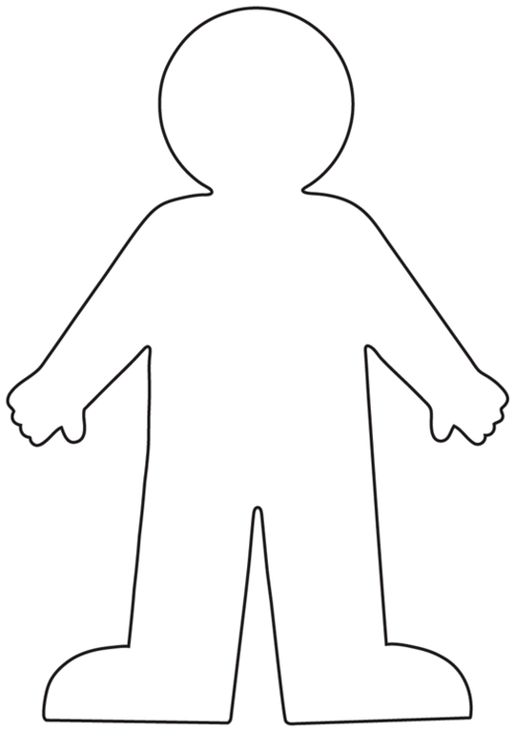

Maths

This week in maths, children have been adding two 4 digit numbers with and without exchange.

Can you complete these problems involving adding ?

True or False?
2345+ 1245= 4561+2345=

4567+3245= 7451+ 3456=

2341+ 1342= 6789+ 1255=

Reading
This term in reading, we have been learning about different reading strategies such as clarifying and evaluating to answer questions based on a text. Using such knowledge can you evaluate a chapter or a short extract that you are reading. Use the stem sentences below to help you.

EVALUATING

In your opinion, what do you like about the text and what impact does it have on you as the reader?

In my opinion, I like the way the author uses _________. It makes me think . . .

I like the words/phrases . . . because . . .

Remember to read for at least ten minutes every day and record the books you have read in your Reading Journal. You can also make a record of new and exciting words you read in there!

Times Tables

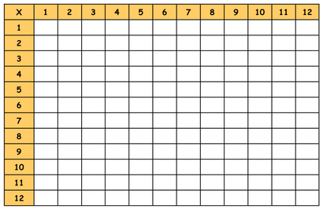
Speed challenge: Complete the blank times tables grid below. Remember to cover up the grid above.

