How to log into Google Classrooms and Accept Invitations for Pupils and Parents

This is a quick guide for using Google Classroom. It covers the use of computers and tablets.

Before you login with your child, please make sure you have logged out other accounts.

For Computers

- On your Laptop / Desktop / Mac / PC, open your Internet Browser, e.g. Chrome, Edge, Firefox or Safari etc.

Then go to classroom.google.com
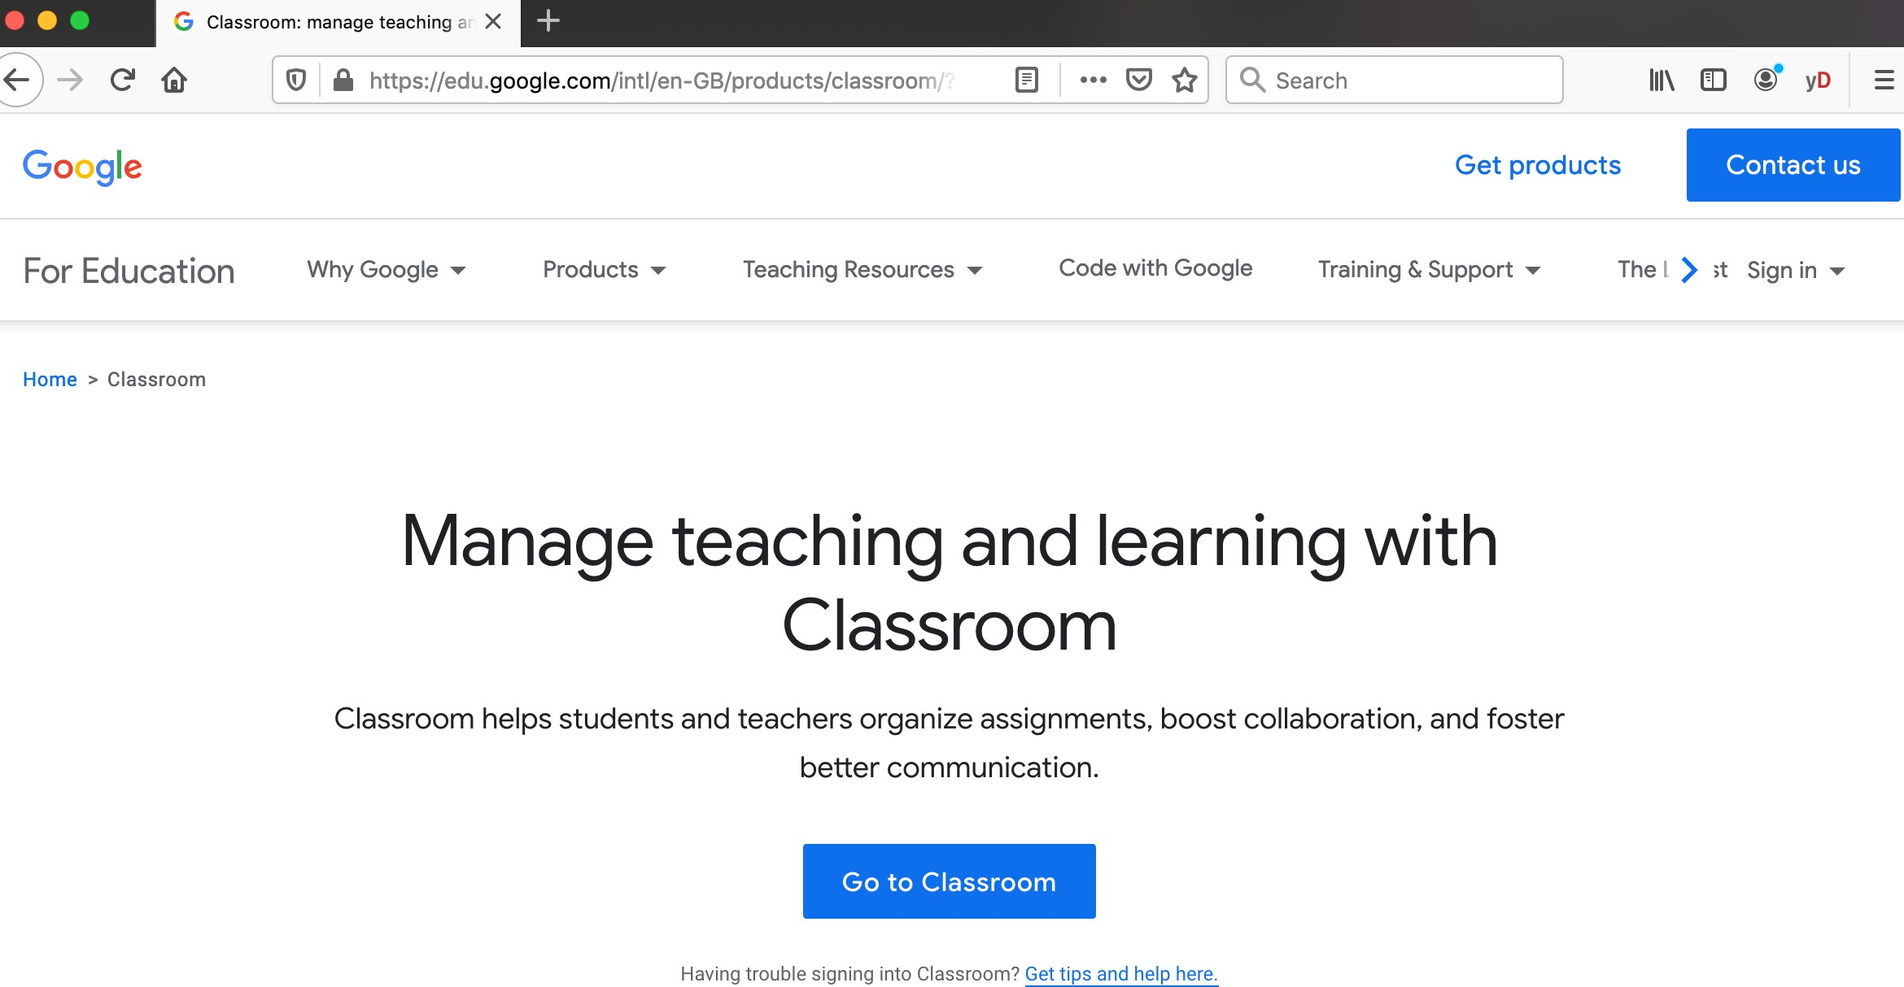

- Type in your G suite login, e.g. jli88.203@westthornton.croydonsch.uk

If you don’t know your G suite username, please contact your class teacher or school

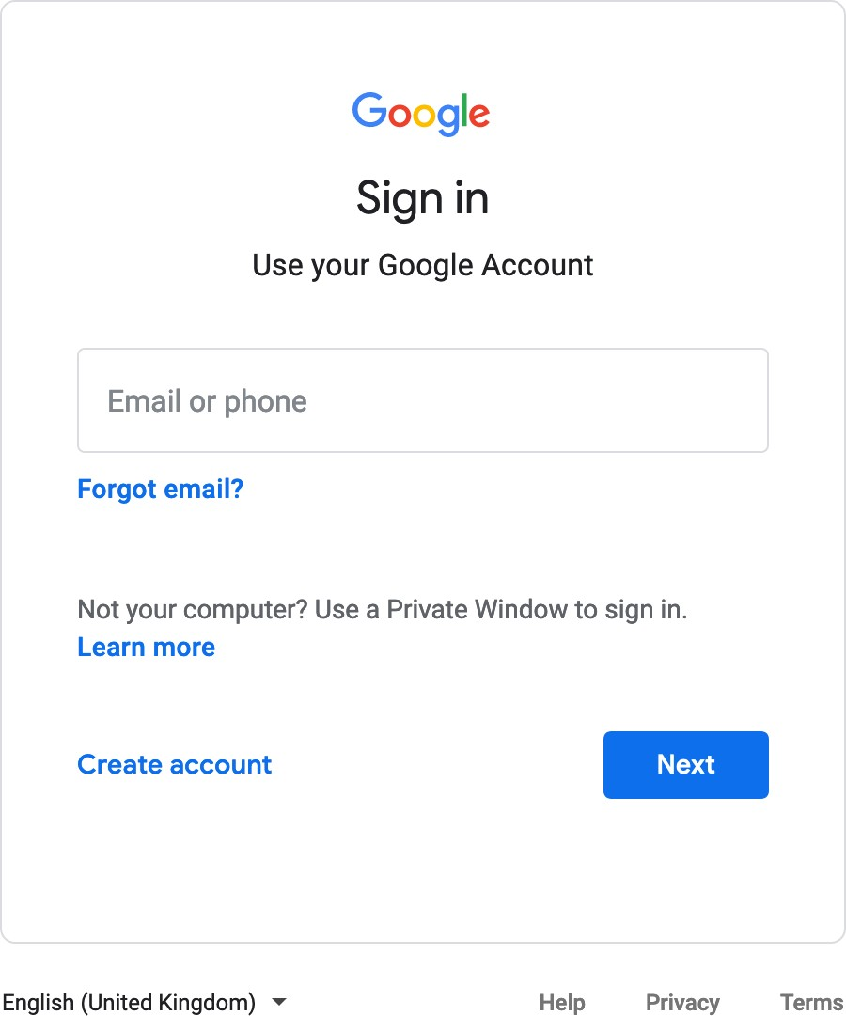

- Enter your password. It’s the same password for your school login.
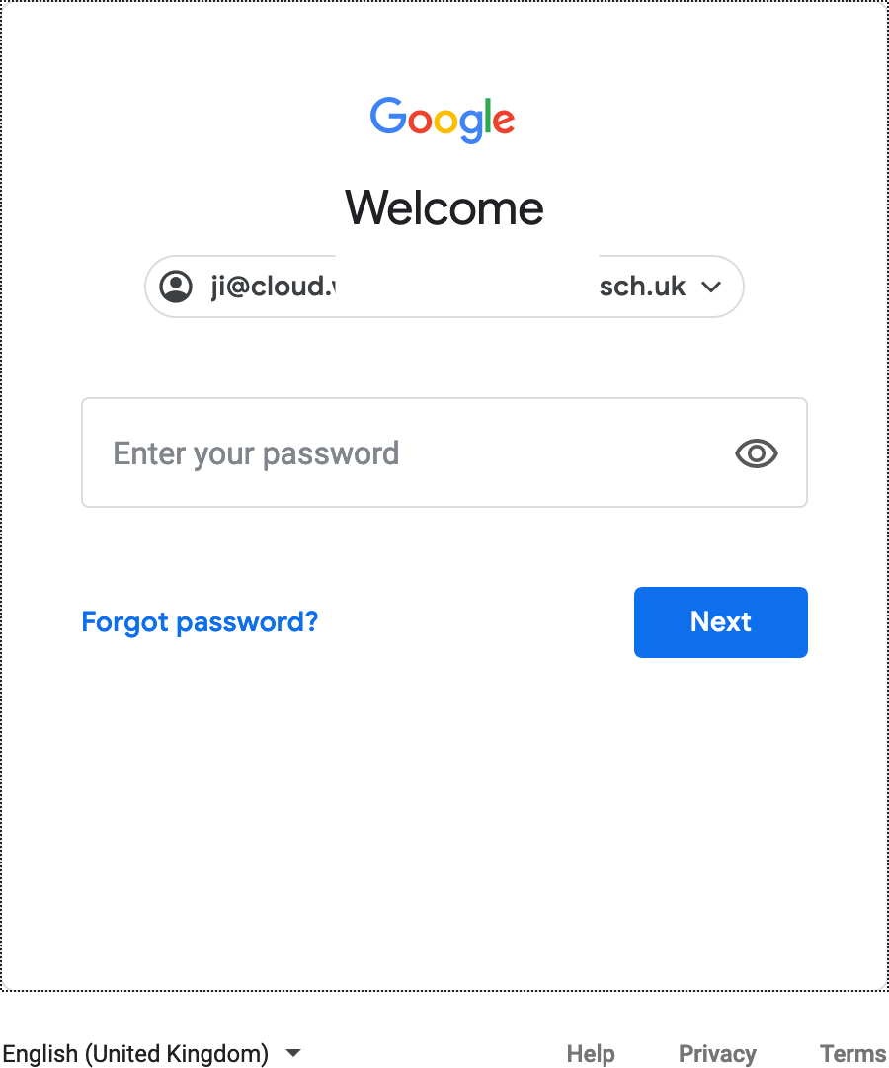

- Please select “I’M A STUDENT”. If you selected “I’m a Teacher” by mistake, please let your IT lead or Plum support know.
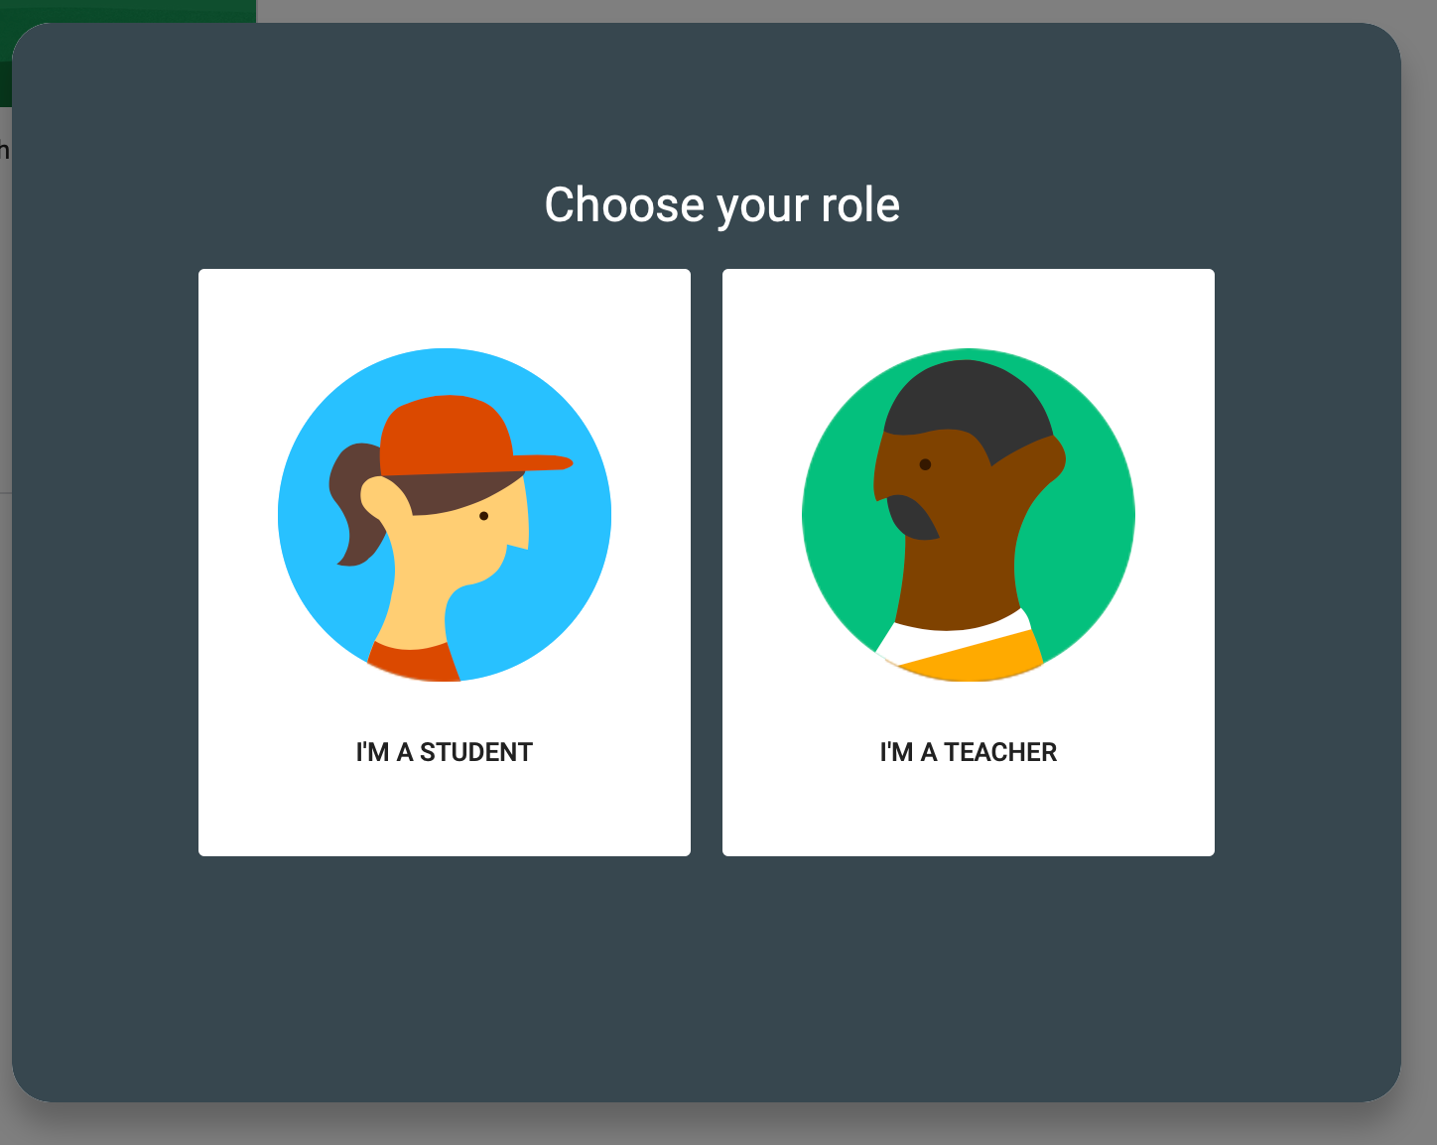

- You will find your classroom invitations. Please click on “Accept”
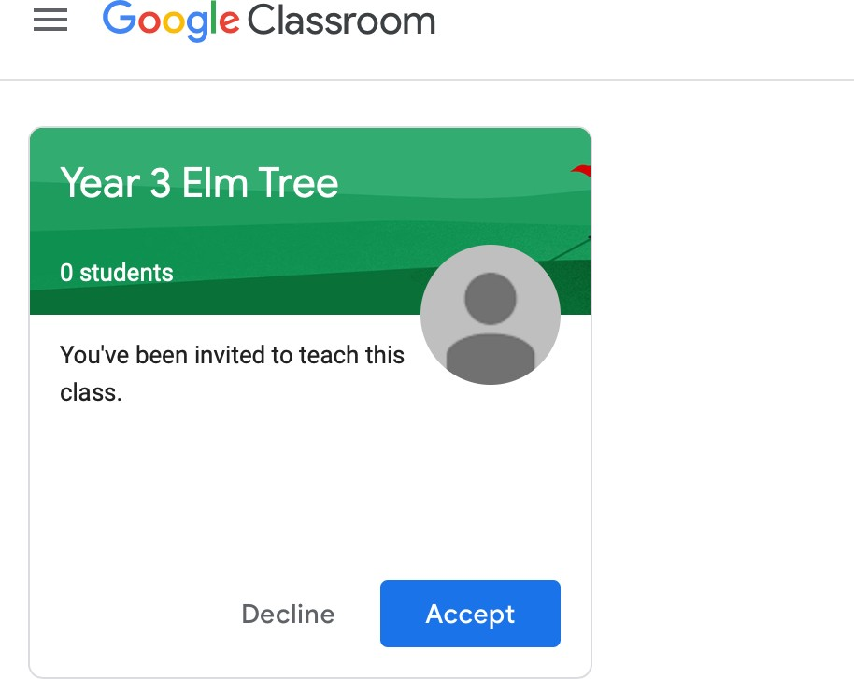

- Now you have access to your Google Classroom. You can communicate with your classmates and teachers in Stream, and find your learning under the Classwork tab.
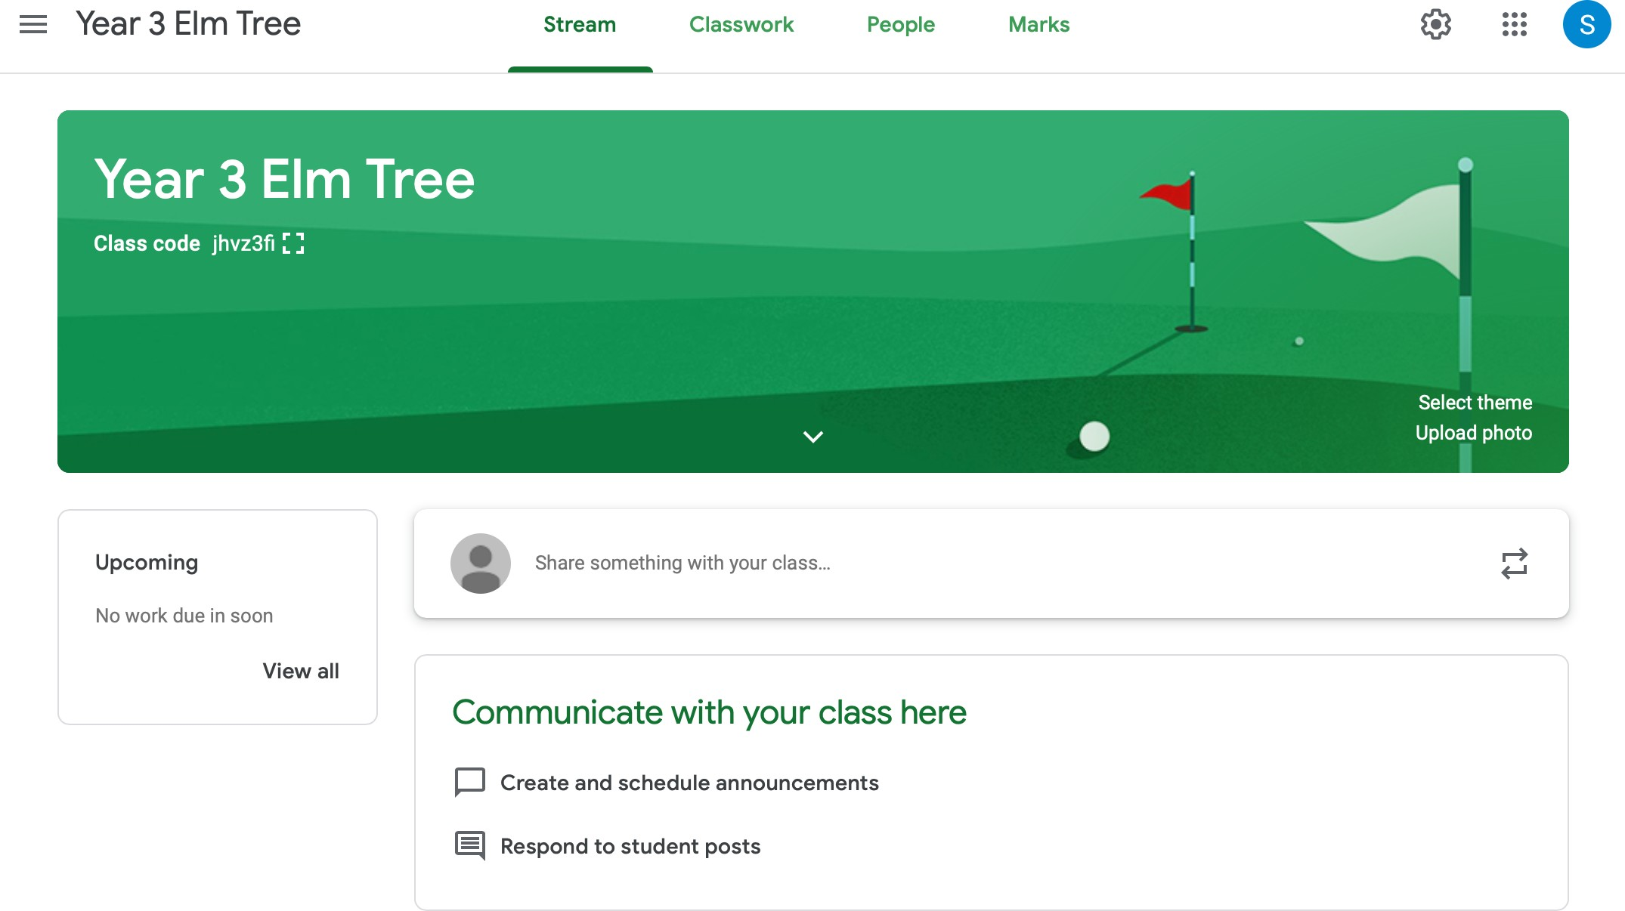

For Tablet

- Please install following Apps on your tablet:

Google Classroom, Google Docs, Google Sheets, Google Slides Google Meet

- Open Google Classroom
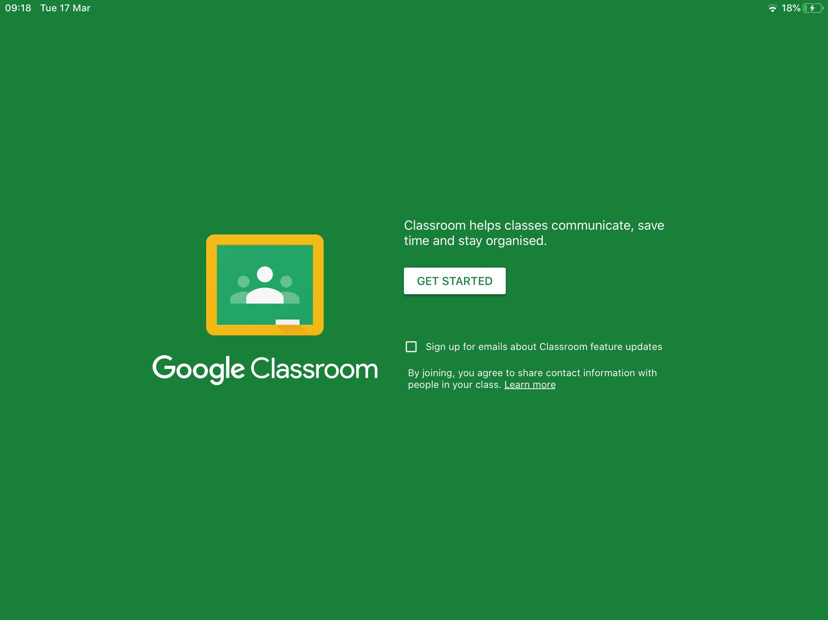
- Sign in with your G suite username e.g. jli88.203@cloud.schoolname.localauthority.sch.uk

If you don’t know your G suite username, please contact your class teacher or school.

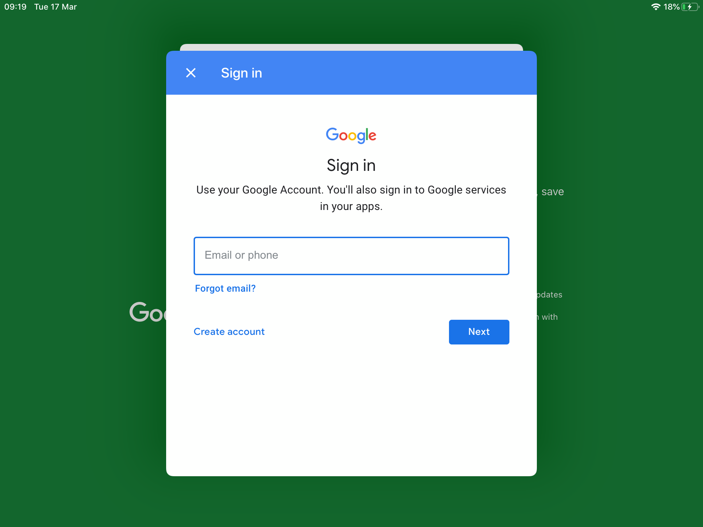

- Tab on JOIN
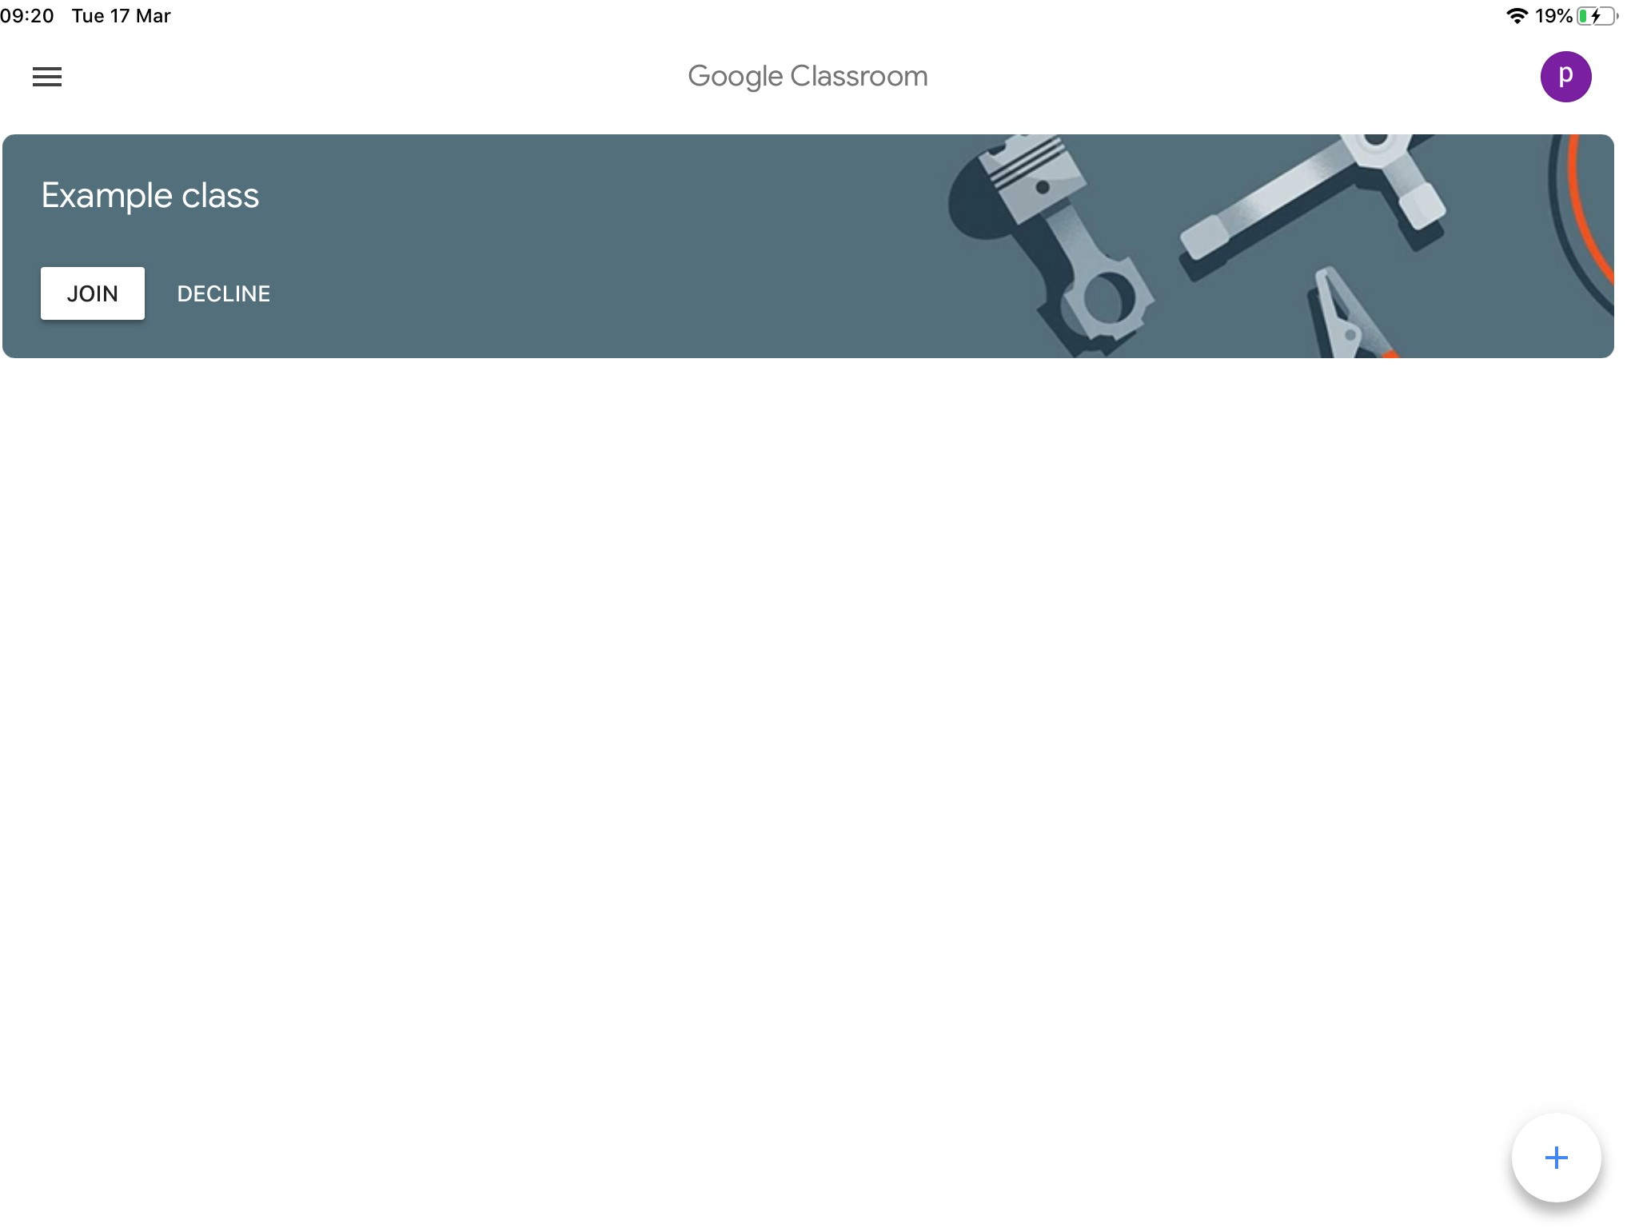
- Now you have access to your Google Classroom. You can communicate with your classmates and teachers in Stream, and find your homeworks in Classwork tab.
